
Name = Muhammad Daniyal Registration no =24371 Submitted to = Mam Faryal

Software Construction and Development

- Lab Assignment -02

Question 1
Write a C++ program that uses pointers to swap two integer numbers entered by the user.
Also, dynamically allocate an array of size n, store values, and print the array.

Input/output:
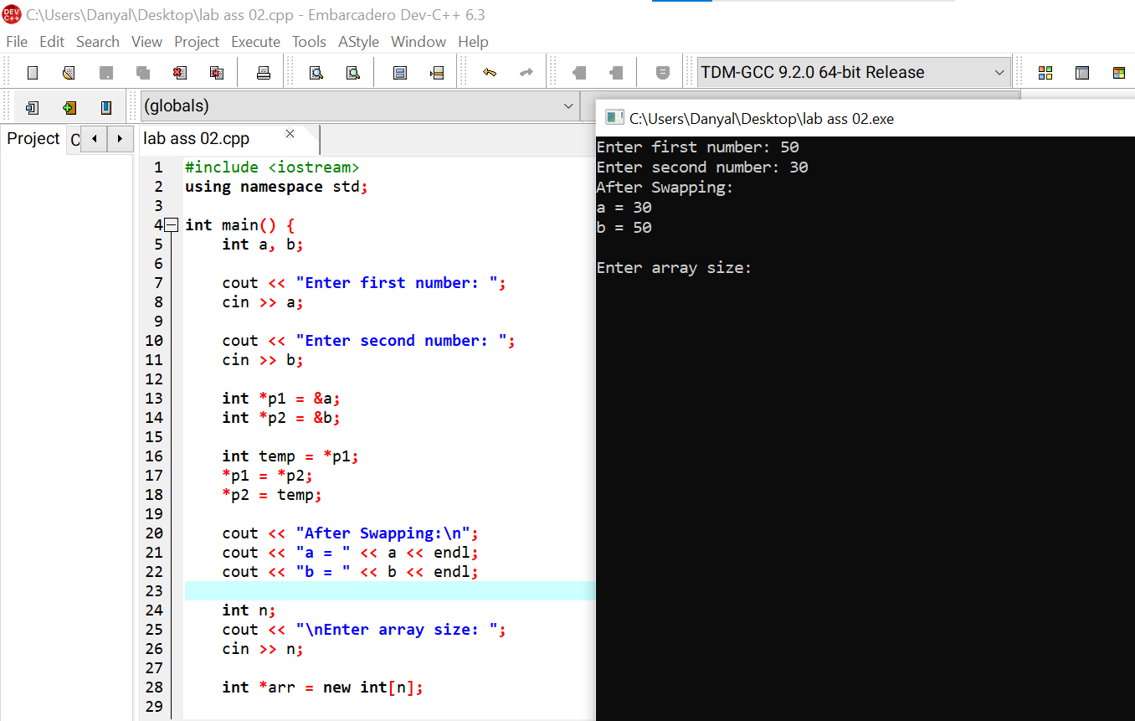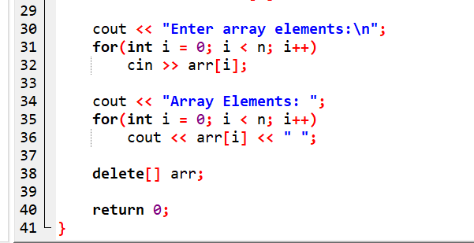

Question 2
Create a structure named Employee containing:
- Name
- ID
- Salary
Write a program to input and display employee information.

Input/output:
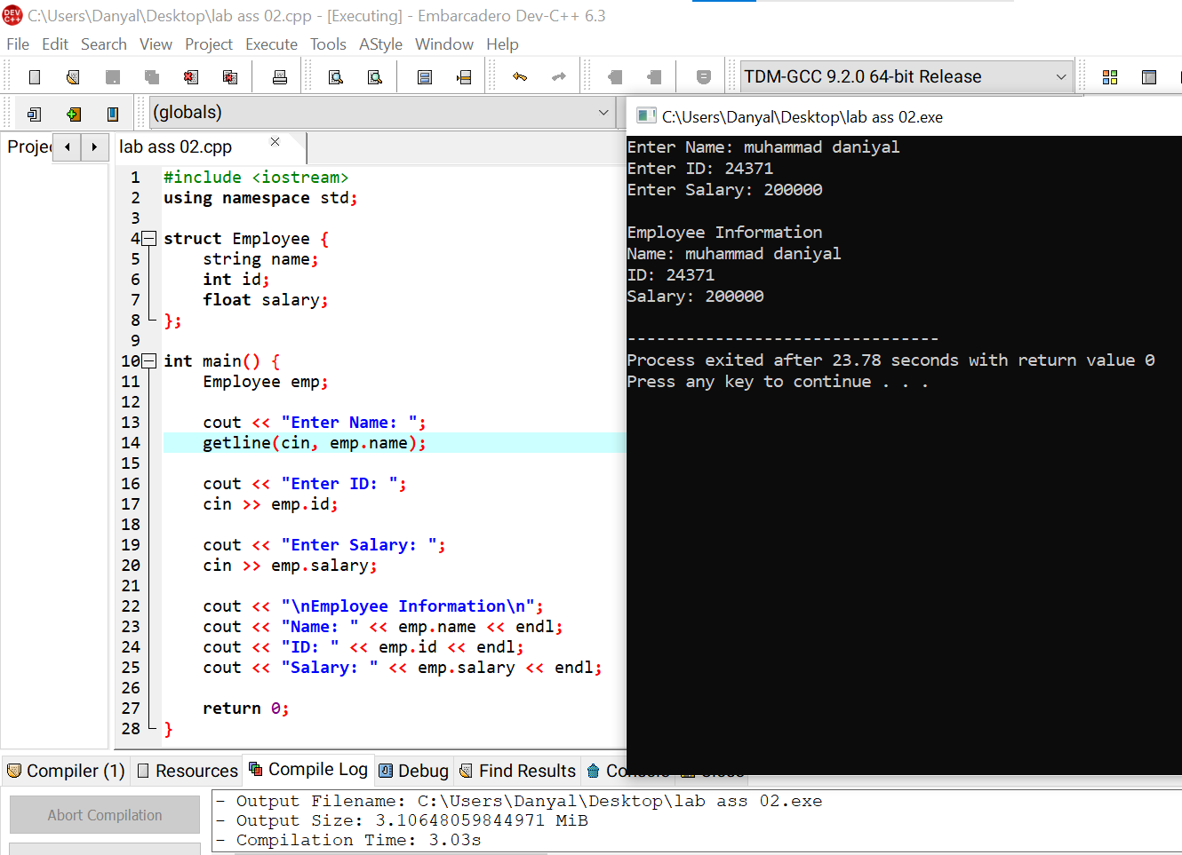

Question 3
Write a C++ program to:
- Store at least three student records (name, marks, grade) in a text file.
- Read the file contents and display them on the screen.

Input/output:
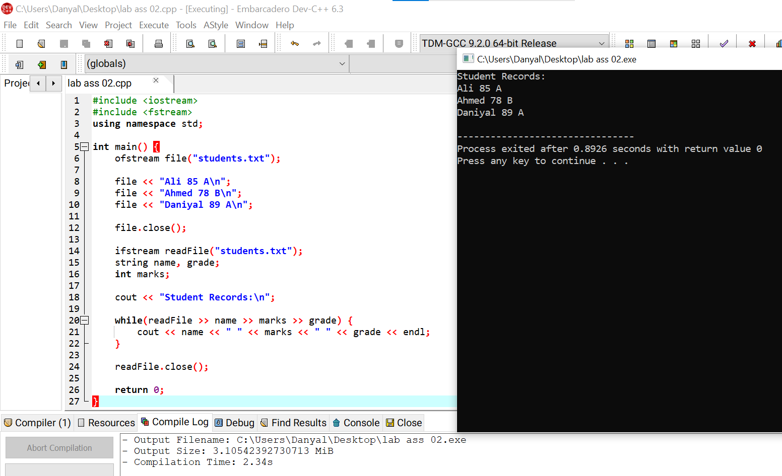

Question 4
Create a C++ class named Circle with:
- Radius as data member
- Constructor to initialize radius
- Member function to calculate area
Create an object and display the area.

Input/output:
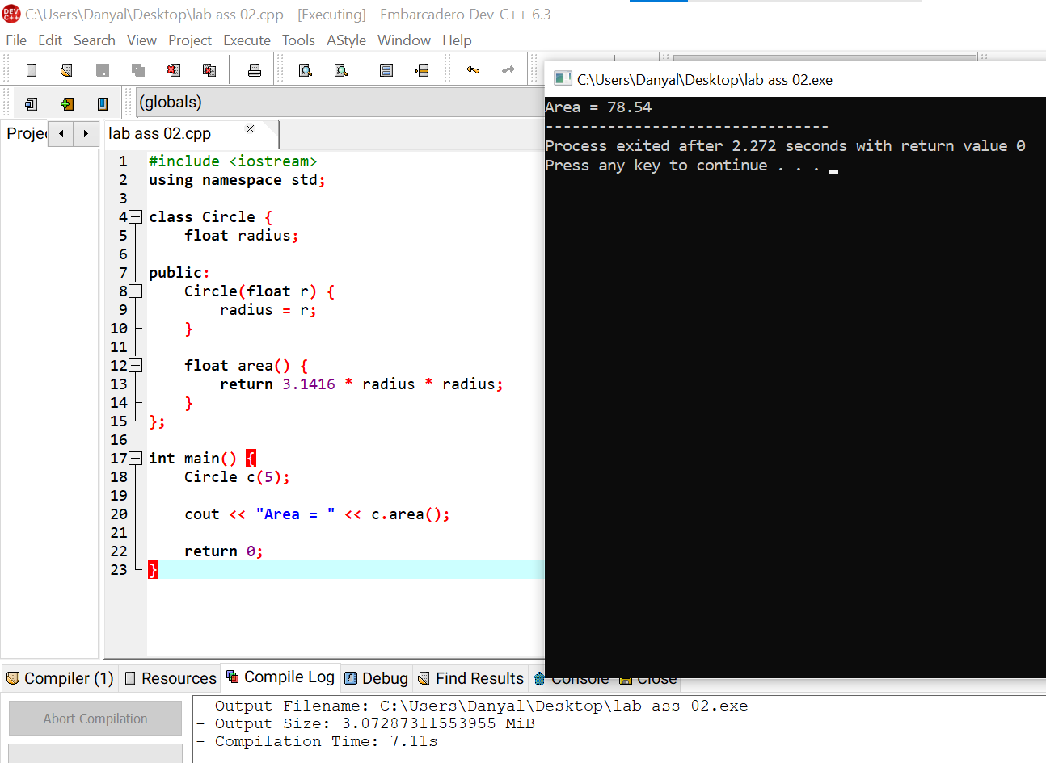

Question 5
Write a C++ program to demonstrate pointer arithmetic by accessing elements of an integer array using pointers.

Input/output:
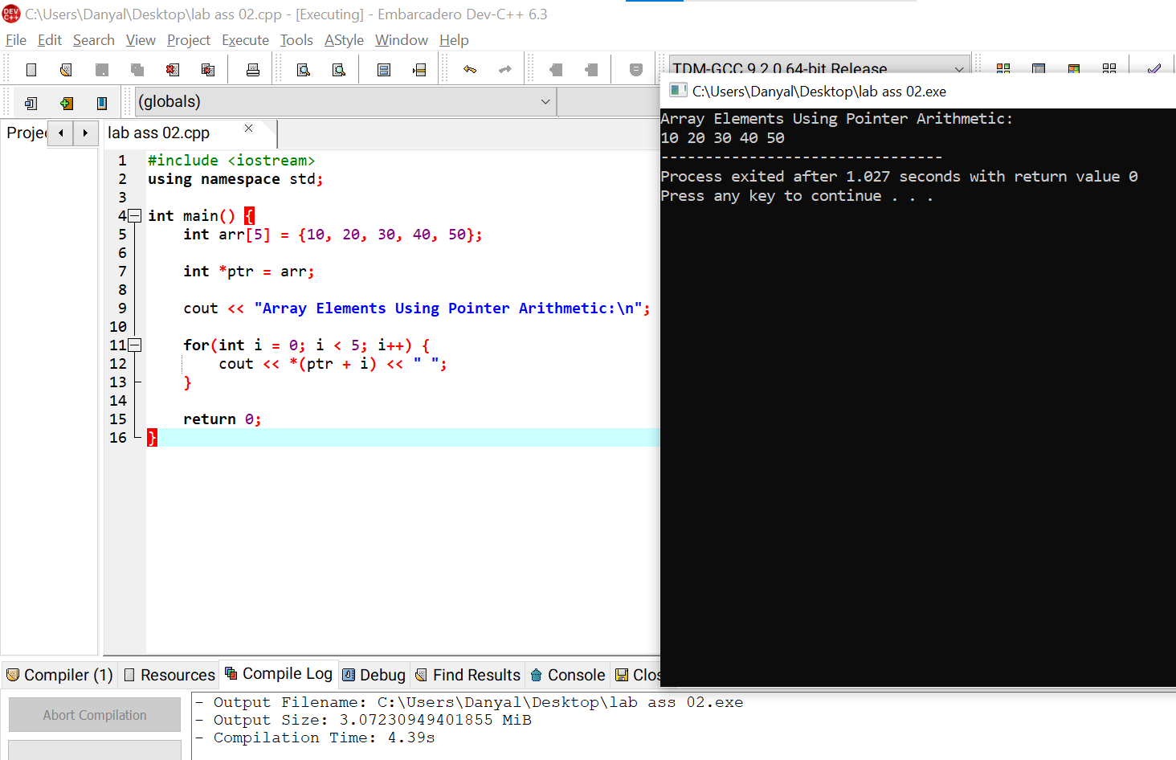

Question 6
Define a structure named Book with the following members:
- Title
- Author
- Price
Write a program to input details of one book and display the information

Input/output:
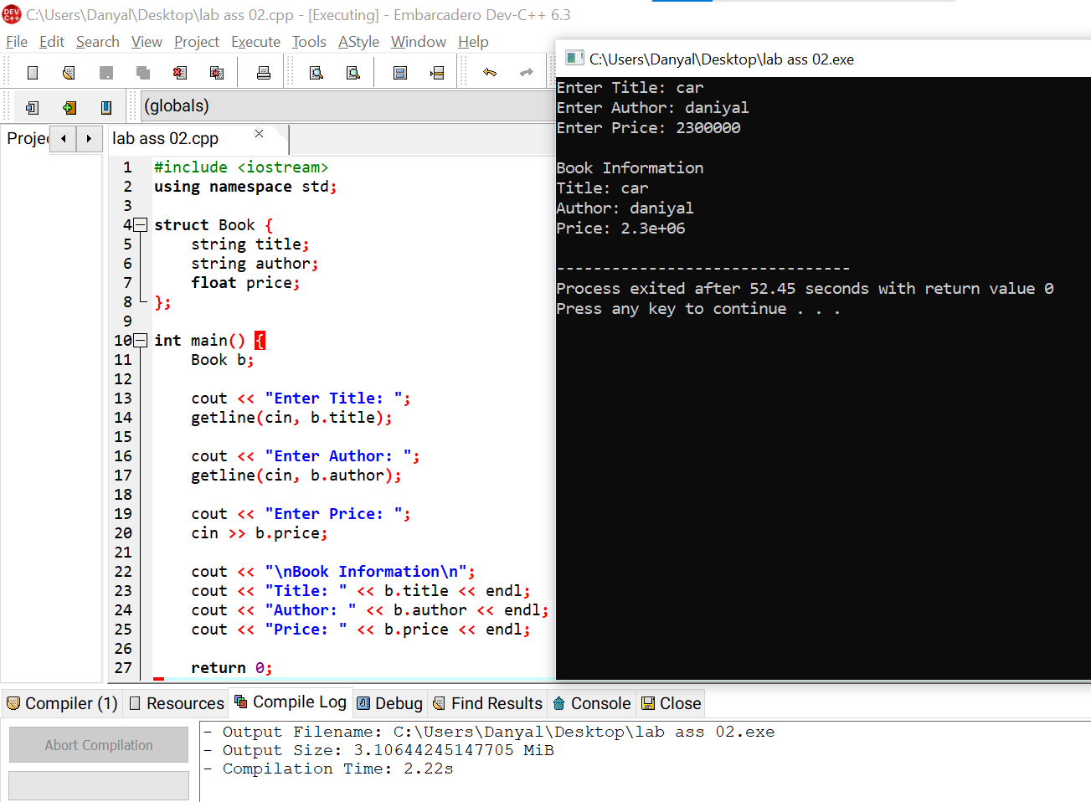

Question 7
Write a C++ program to create a class named Student with:
- Name
- Roll number
- Marks
Include a member function to calculate and display whether the student has passed or failed.

Input/output:
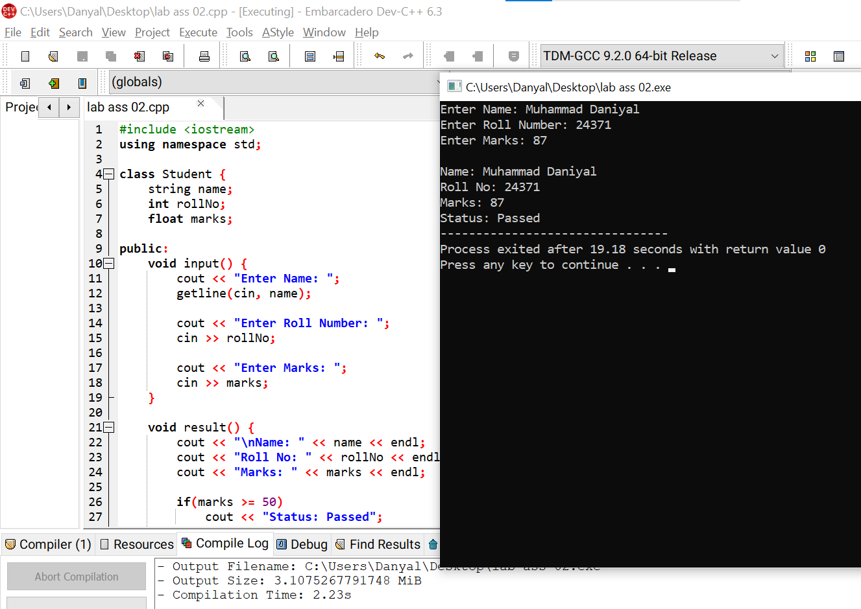

Question 8
Write a C++ program that writes product details (product name, quantity, price) to a file and then reads and displays the data.

Input/output:
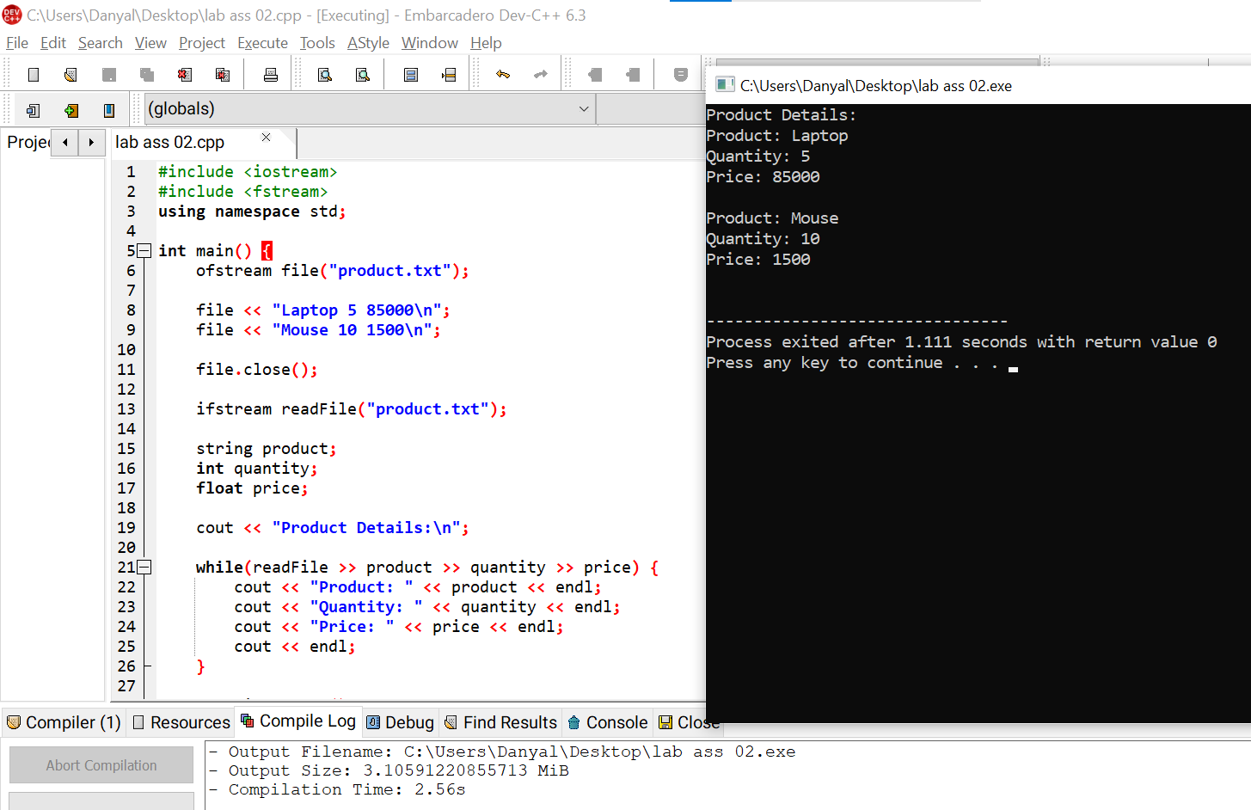

Question 9
Create a C++ class named Rectangle with:
- Length
- Width
Include member functions to calculate area and perimeter, then display both using an object of the class

Input/output:
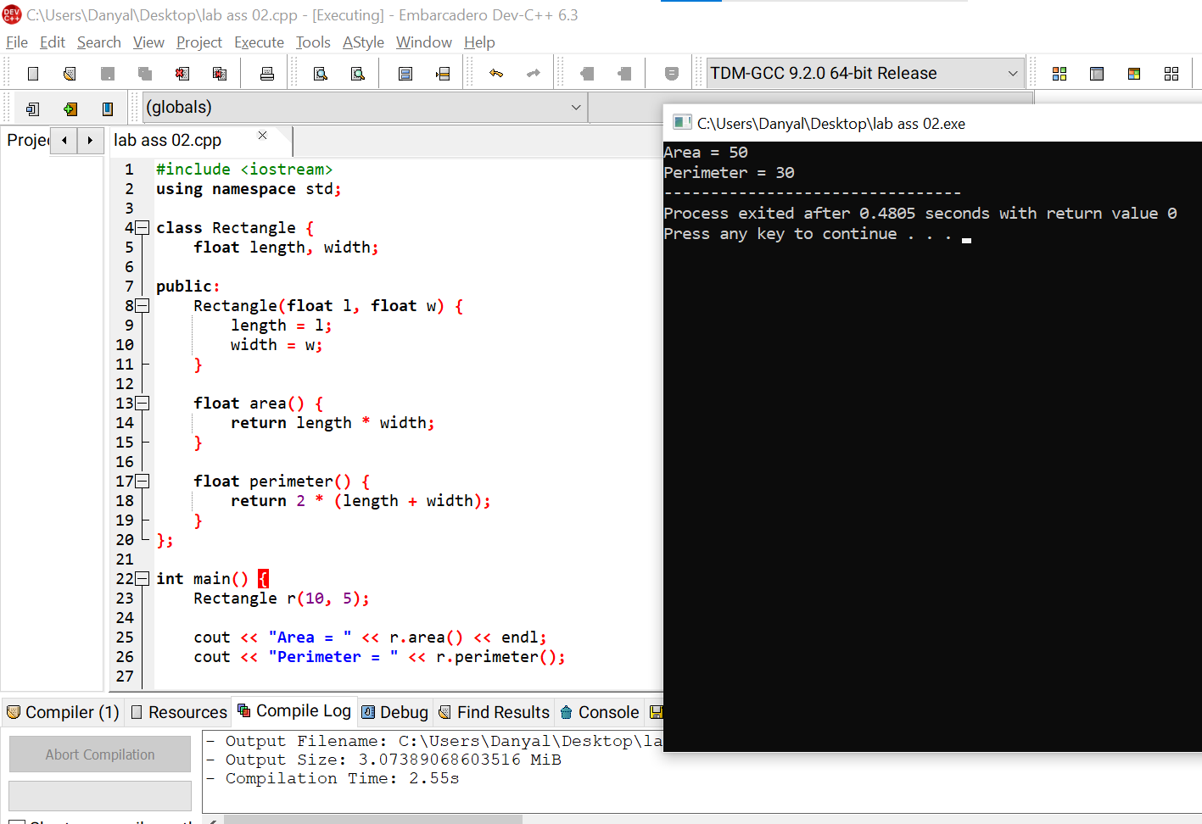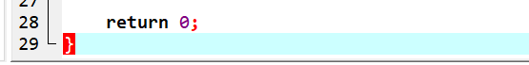

Question 10
Write a C++ program to dynamically allocate memory for a single integer using a pointer, assign a value to it, display the value, and then deallocate the memory.

Input/output:
